**Eric Morse Stereo Audio Amplifier PCB Test Plan**

1. **Introduction**

This PCB device is a stereo audio amplifier. It takes in a stereo audio input, composed of two PWM signals and respective grounds, as well as 3.3V input wire to power the LM4910MA capacitor-less op amp. A PWM signal is a common signal used to make speakers play audio sounds. The only output is a stereo audio jack that a person can connect a headphone to (output holes are identical to input, except room is made on the PCB board for the output audio jack to be mounted on the board and the output does not have a 3.3V power wire). The user controls the volume of the audio amplifier by turning one of two potentiometers. The right channel potentiometer alters the volume intensity of the PWM signal (audio) coming out of the right channel (which would be the right-ear headphone, if the user connects headphones to the jack). The left channel potentiometer alters the volume intensity of the PWM signal (audio) coming out of the left channel.

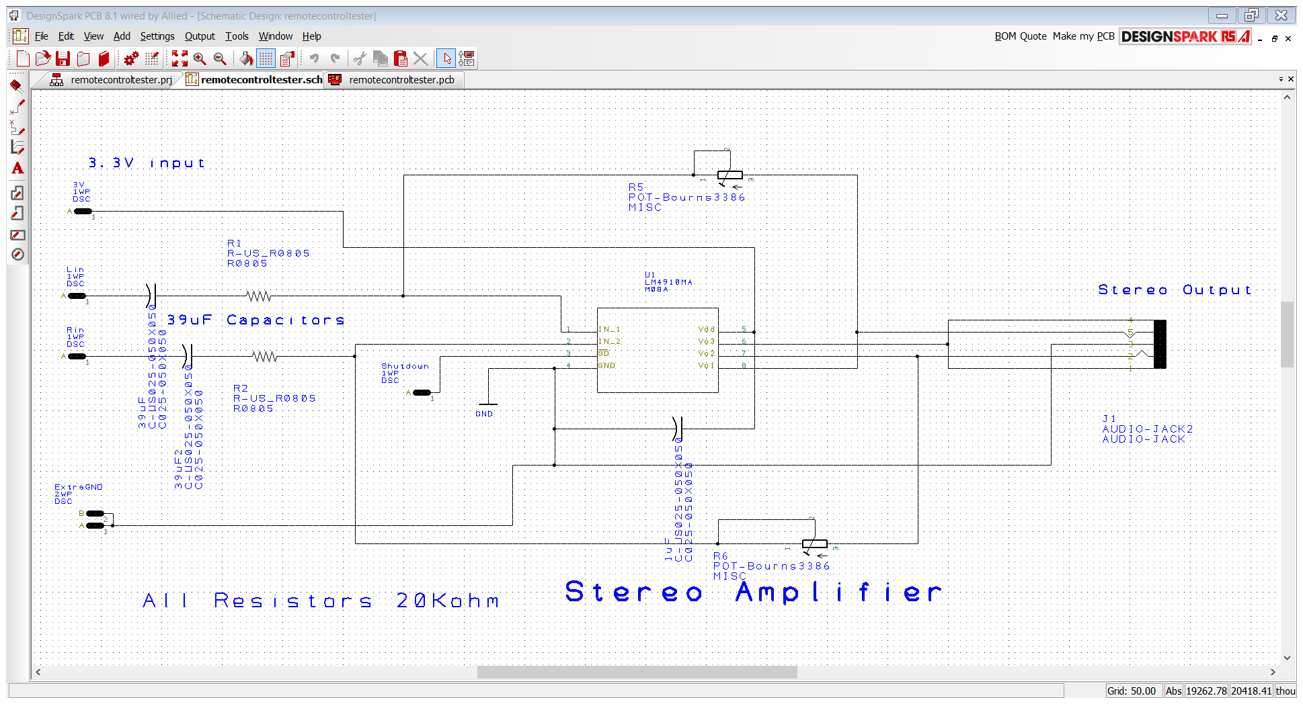

Figure 1: Stereo Amplifier schematic

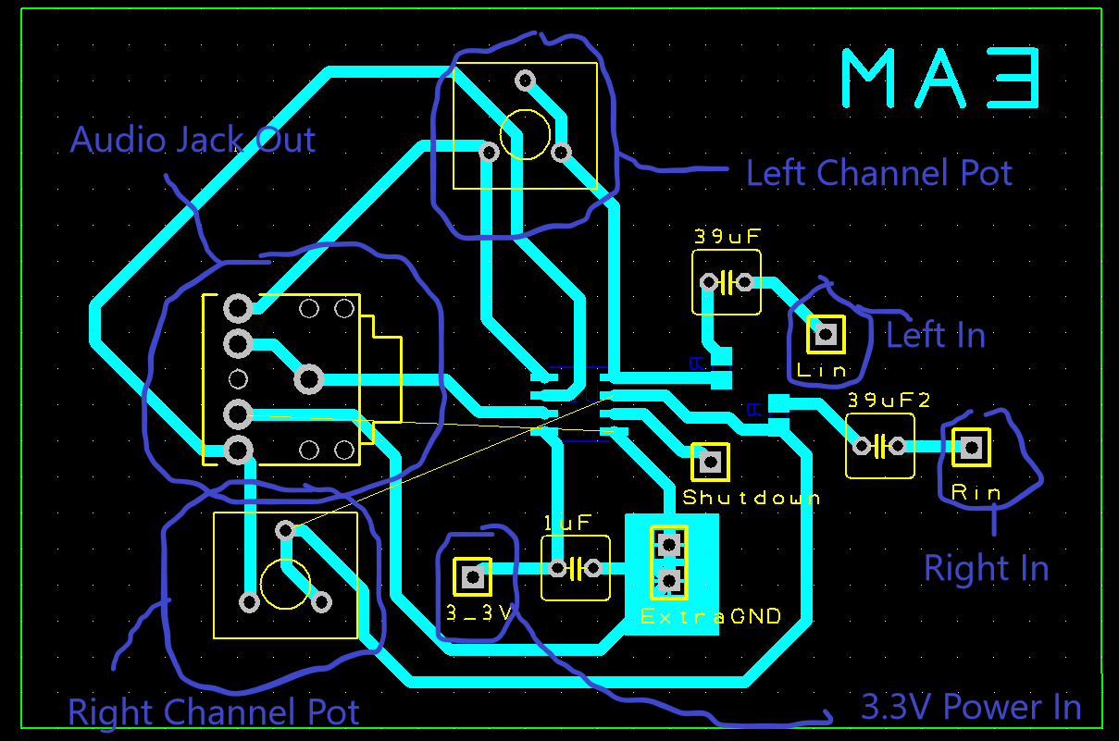

Figure 2: PCB Design of Stereo Amplifier

1. **Requirements**

|  |  |  |
| --- | --- | --- |
| **ID** | **Requirement Description** | **Verified By** |
| PCB-1 | The system shall accept two PWM signals for inputs as well as 3.3V DC input signal | Inspection |
| PCB-2 | The system shall allow adjustment of volume of each analog audio channel independently | Experiment |
| PCB-3 | The system shall scale volume from off to loud enough to be easily heard by people with normal hearing in an open room with typical levels of background noise using audio speakers that could connect to the system. | Demonstration |
| PCB-4 | The system shall not alter the frequency of the analog signals. | Experiment |
| PCB-5 | The system’s output offset voltage shall be less than 50 mV for a 440Hz sine input at the PWM inputs. | Experiment |

1. **Testing Procedure**

Equipment List

1 Function Generators

1 Oscilloscope

1 Power Unit

To test PCB-1

1. Locate the 3.3V DC Power In hole on bottom of the board.
2. Connect an electrical wire to the hole, and make sure that the wire fits into the hole.
3. Locate the left channel input on the upper right side of the board.
4. Connect an electrical wire to that hole, and make sure that the wire fits into the hole.
5. Locate the right channel input immediately below the left channel input.
6. Connect an electrical wire to that hole, and makes sure that the wire fits into the hole.
7. Be sure to connect ground to either of the available ground holes as well.
8. This test passes.

To Test PCB-2

1. Set Function generator to 3.3V DC and connect it to 3.3V DC hole on the bottom of the board.
2. Set Function generator to output two 440 Hz 0.5V amplitude sinusoidal signals to the left channel and right channel PWM input holes on the right side of the PCB board.
3. Be sure to connect ground to either of the available ground holes as well.
4. Connect oscilloscope to audio jack terminal on the left side of PCB board.
5. Rotate only one potentiometer; you should see the amplitude of only one channel of the audio jack change.
6. Rotate the other potentiometer; you should only see the amplitude of the other channel of the audio jack change.
7. This test passes

To Test PCB-3

1. Bring all equipment to an open room that is populated with people.
2. Set Function generator to 3.3V DC and connect it to 3.3V DC hole on the left side of the board.
3. Set Function generator to output two 440 Hz 0.5V amplitude sinusoidal signals to the left channel and right channel PWM input holes on the right side of the PCB board.
4. Be sure to connect ground to either of the available ground holes as well.
5. Make sure that both potentiometers are rotated counter clockwise so that no sound plays.
6. Connect stereo audio cable from audio jack on the left side to a stereo audio speaker.
7. Slowly rotate both potentiometers clockwise to increase the volume, while being careful to not let the volume reach 120 dB, which is the volume of a rock concert (it does not need to be measured, use your own judgement of “dangerously loud”).
8. Make sure that dangerously load levels of sound can not be produced by the audio amplifier.
9. Make sure everyone in the room can clearly hear the sound coming out of the speakers.
10. This test passes.

To Test PCB-4

1. Set Function generator to 3.3V DC and connect it to 3.3V DC hole on the bottom of the board.
2. Set Function generator to output two 440 Hz 0.5V amplitude sinusoidal signals to the left channel and right channel PWM input holes on the right side of the PCB board.
3. Be sure to connect ground to either of the available ground holes as well.
4. Connect oscilloscope to audio jack terminal on the left side of PCB board.
5. Measure and compare frequencies of all PWM inputs and outputs. The frequencies of left channel at the input and output side should be identical, and the frequencies of the right channel at the input and output side should be identical as well.
6. This test passes.

To Test PCB-5

1. Set Function generator to 3.3V DC and connect it to 3.3V DC hole on the bottom of the board.
2. Set Function generator to output two 440 Hz 0.5V amplitude sinusoidal signals to the left channel and right channel PWM input holes on the right side of the PCB board.
3. Be sure to connect ground to either of the available ground holes as well.
4. Connect oscilloscope to audio jack terminal on the left side of PCB board.
5. Measure DC offset of both PWM output channels. DC offsets should be less than 50mV.
6. This test passes.
7. **Data and Expected Results**

For PCB-1

|  |  |  |
| --- | --- | --- |
| Pin hole to be located | Able to locate pin hole? | Wire properly fit into pin hole? |
| 3.3V DC pin hole | Yes | Yes |
| Left channel PWM input pin | Yes | Yes |
| Right channel PWM input pin | Yes | yes |

Did PCB-1 pass? Yes

For PCB-2

|  |  |  |  |
| --- | --- | --- | --- |
| Channel amplified | Measurements: Amount other channel changed? | Expected result of other channel | % Error |
| Left | 0V | 0V | 0 |
| Right | 0V | 0V | 0 |

Did PCB-2 pass? Yes

For PCB-3

|  |  |  |  |  |  |
| --- | --- | --- | --- | --- | --- |
| Did audio play? | Expected result | Did people in the room hear it? | Expected result | Did it reach dangerous levels of volume? | Expected result |
| No | Yes | No | Yes | No | No |

Did PCB-3 pass? No

For PCB-4

|  |  |  |  |  |  |  |
| --- | --- | --- | --- | --- | --- | --- |
| The channel used | Measured input frequency | Expected input frequency | % Error | Measured output frequency | Expected output frequency | % Error |
| Left | 439Hz | 440Hz | -0.23 | 0 | 440Hz | -100 |
| Right | 441Hz | 440Hz | 0.23 | 0 | 440Hz | -100 |

Did PCB-4 pass?

For PCB-5

|  |  |  |
| --- | --- | --- |
| Channel used | Measured DC offset at output | Maximum DC Offset test allows |
| Left | 0V | 50mV |
| Right | 0V | 50mV |

Did PCB-5 pass? Yes

1. **Conclusion**

The purchased parts from mouser.com that were used to fabricate the pcb board were the wrong size and of poor make. These oversized parts created a short between the inputs and ground causing none of the current to travel to the output. As a result, the pcb fabrication failed most of the PCB requirements. Better care to purchase the proper parts will be carried out from now on.